Investments and Insurance.....IT IS NOT THAT COMPLICATED!!

We often wonder.... ‘Why is someone richer than me?’

- Have you ever wondered how the rich got their wealth and then kept it growing?
- Do you earn a lot but end up poorer than your neighbour who saves a lot?
- Why do the “get rich quick” schemes NEVER favour you?
- Do you know that you should invest, but don't know where to start?
- Are you sufficiently providing for the needs of your dear ones, in case of any unforeseen contingency in life?

If your answer is yes to any of the above, then this article is perfect for you. It covers the basic concepts of investing and insuring.
The world of finance can be extremely risky if you go with “rumours, tips, gossips” but we firmly believe that the stock market and the financial world overall won't seem so complicated once we run you through its basic concepts of using fundamentals v/s rumours as the key basis of investments.

We should emphasise, however, that investing isn't a get-rich-quick scheme. Investing is a task requiring patience, knowledge and effort. But needless to say, the returns far outweigh the efforts. Through this article we hope to familiarise you with the concepts of inflation, compounding and diversification.

Why should I worry about Inflation?

Inflation is when the price of goods and services rises over time, this can occur for several reasons, like their demand growing faster than their supply, or when companies increase the cost of goods to maintain profit margins. In other words, inflation means the loss in the value of your money.
In simple words, it implies that the same amount of money will get you less goods in the future, than it does at present. However, this does not mean that you cannot fulfil your plans for the future. There exists a simple way to prevent your money from losing its value – Investing. To beat inflation, all you need to do is invest in instruments with a higher rate of return than inflation. For example, investing wisely in equity mutual funds for the long term as against fixed deposits.

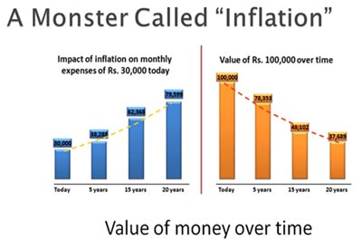

What is 'Compounding'?

Compounding is the process where the value of an investment increases because the earnings on an investment, both capital gains and interest, earn interest as time passes. This exponential growth occurs because the total growth of an investment along with its principal earns money in the next period. This differs from linear growth, where only the principal earns interest each period. In equity share investing , say you buy good quality shares for Rs 10 lakhs and hold them for 15 years, even if the same grows at 15%pa including Dividends paid, your initial investment grows to Rs 71 lakhs – as an illustration

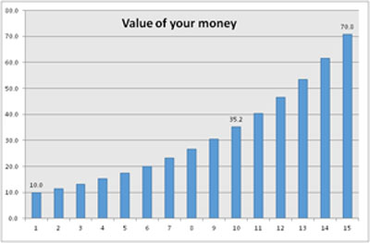

The Basics of Investing
What does investing mean? It's actually quite simple. Investing means putting your money to work for you. While you are working hard in your profession or your business, you can also make your money work equally hard for you, allowing you to take a long vacation, or socialise with friends or simply relax. Making your money work for you maximises your earning potential whether or not you receive a raise, decide to work overtime or look for a higher-paying job.
There are many different ways you can go about making an investment. This includes putting money into stocks, bonds, mutual funds, or real estate (among
many other things). But the starting point is DON’T SPEND IT ALL, SAVE SOME FIRST.

.

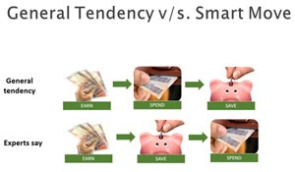
What are the different types of Investments available today?

Gone are the days when we had limited investment options like post office savings, FDs or LIC.
Look at the wide range of options available now.
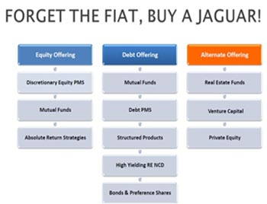

Bonds (Tax-free or Taxable) / Deposits
The term bond is commonly used to refer to any security that gives you a fixed rate of interest. When you purchase a bond, you are lending out your money to a company or the government. In return, they agree to give you interest on your money and eventually pay you back the amount you lent out.

The main attraction of bonds is their relative safety. If you are buying bonds from a stable government, your investment is virtually guaranteed, or risk-free. The safety and stability, however, come at a cost. Because there is little risk, there is little potential return. As a result, the rate of return on bonds is generally lower than other securities. FOR ANY BOND, PLEASE CHECK THE RATING which is done by a Rating Agency.AAA+ rating is the highest though frankly anything upto AA should be worth investing in as a general thumb rule. For UNRATED deposits / bonds, THINK TWICE. Higher the rate, higher is the risk of default. PLEASE ALSO NOTE THAT ALL COMPANY DEPOSITS ARE UNSECURED. Consult your financial adviser before investing.

Equity Shares
When you purchase shares, you become a part owner of that business. This entitles you to vote at the shareholders' meeting and allows you to receive any profits that the company allocates to its owners. These profits are referred to as dividends. So if you own even 1 share of ACC, you are a proud owner of one of the largest Cement company in India. THINK THAT WAY.

While bonds provide a steady stream of income, stocks are volatile. That is, they fluctuate in value on a daily basis. When you buy a stock, you aren't guaranteed anything. Many stocks don't even pay dividends, in which case, the only way that you can make money is if the stock increases in value - which might not happen.

Compared to bonds, stocks provide relatively high potential returns. Of course, there is a price for this potential: you must assume the risk of losing some or all of your investments in order to stand a chance of earning the above mentioned “high returns”. Equity shares thus are called “GROWTH CAPITAL”. Equities always give substantially high returns than bonds/deposits over long investment periods, say 5 to 10 years and we strongly recommend a wise mix of both. The need to consult your expert financial adviser in this case, is 100x more than for Bonds above.

Why do we advocate a fair mix of Equity Shares in your long term portfolio?

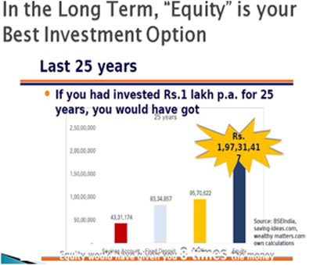

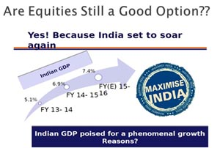

Mutual Funds
A mutual fund is a collection of stocks and bonds. When you buy a mutual fund, you are pooling your money with a number of other investors, which enables you (as part of a group) to pay a professional manager to select specific securities for you. Mutual funds are all set up with a specific strategy in mind, and their distinct focus can be nearly anything: large stocks, small stocks, bonds from governments, bonds from companies, stocks and bonds, stocks in certain industries, stocks in certain countries, etc.

The primary advantage of a mutual fund is that you can invest your money without the time or the experience that are often needed to choose a sound investment. Theoretically, you should get a better return by giving your money to a professional than you would if you were to choose investments yourself. Mutual Funds are generally liquid so you can get your cash out easily by redeeming them at short notice.

Unit Linked Insurance Plans or ULIPs

ULIPs are similar to Mutual Fund units above but the only difference is that these COMBINE Insurance with Investments thus giving you a powerful combi product. They are gaining immense popularity as they now provide cost competitive solutions for long term security and investments. ULIPs however are recommended for only those investments which you want to lock in for more than 5years. That way you give a chance to your equity component to COMPOUND at a higher pace than sell out too early when you make a profit.
ULIPs are an ideal gift for your children, or grand children. By choosing a mix of high growth equity and partly debt, you can save during your earning years to provide for a large corpus for their education, marriage, or simply for their own wealth when they need it when they grow.

Alternative Investments
Futures, FOREX, Gold, Real Estate, Etc.
So, you now know about the two basic securities: equity and debt, better known as stocks and bonds. While many (if not most) investments fall into one of these two categories, there are numerous alternative vehicles, which represent the most complicated types of securities and investing strategies. These are generally high-risk/high-reward securities that are much more speculative than plain old stocks and bonds. Yes, there is the opportunity for big profits, but they require some specialised knowledge.

What is a Portfolio?
A portfolio is a combination of different investment assets mixed and matched for the purpose of achieving an investor's goal(s). Items that are considered a part of your portfolio can include any asset you own - from real items such as art and real estate, to equities, fixed-income instruments and their cash and equivalents.
An easy way to think of a portfolio is to imagine a pie chart, whose portions each represent a type of vehicle to which you have allocated a certain portion of your whole investment. The asset mix you choose according to your aims and strategy will determine the risk and expected return of your portfolio.
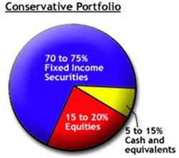 | 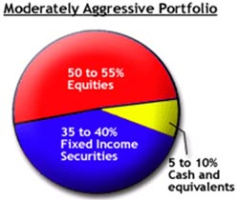

The conservative investment strategies, which put safety at a high priority, are most appropriate for investors who are risk averse and have a shorter time horizon. Conservative portfolios will generally consist mainly of cash and cash equivalents, or high-quality fixed-income instruments.
Aggressive investment strategies - those that shoot for the highest possible return - are most appropriate for investors who, for the sake of this potential high return, have a high risk tolerance (can stomach wide fluctuations in value) and a longer time horizon. Aggressive portfolios generally have a higher investment in equities.

Do you know how well Insured you are to protect your dear ones in case of an unforeseen contingency?

